Objective
Containerize a microservices-based application using Node.js, Docker, and Docker Compose.
Task Overview
You are provided with source code for three Node.js microservices:
- User Service (Port 3000)
- Product Service (Port 3001)
- Order Service (Port 3002)
- Gateway Service (Port 3003)
Your task is to containerize these services and orchestrate them using Docker Compose.
Requirements
1. Dockerfile Creation
Create a Dockerfile for each service (3 services × 5 marks) that:
- Uses an appropriate Node.js base image
- Sets a working directory
- Installs dependencies
- Exposes the correct port
- Includes a valid CMD instruction
2. Docker Compose Configuration
Create a docker-compose.yml file that:
- Defines all three services
- Maps correct ports
- Configures a shared network for communication
3. Local Testing & Validation
Run the application using docker-compose up on your local machine.
- Ensure all services start correctly
- Confirm accessibility via localhost on respective ports
Execution
- Cloning the repo after forking the original repo

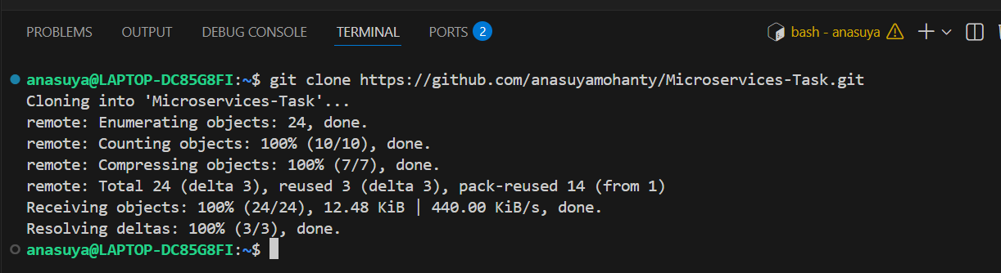

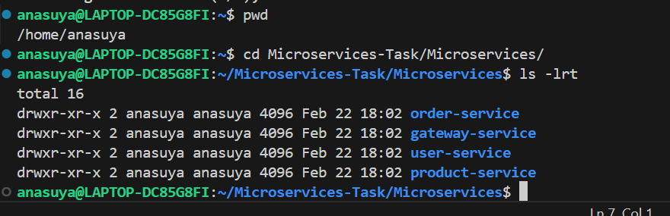

- Create a Dockerfile for each service
  - User-service :
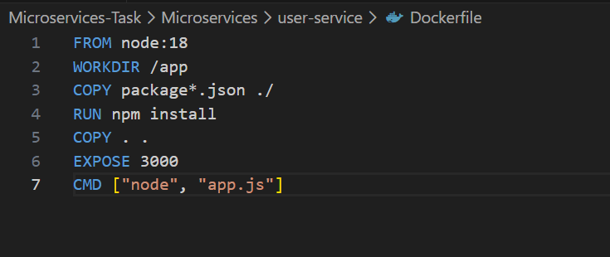
  - Product-service:
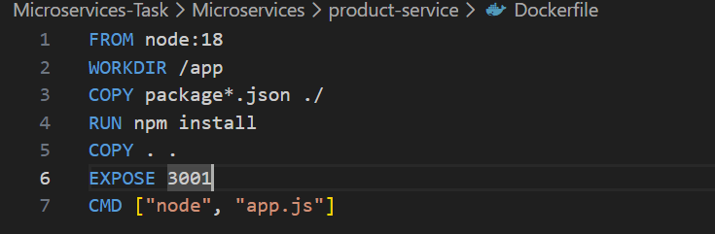

  - Order-service:
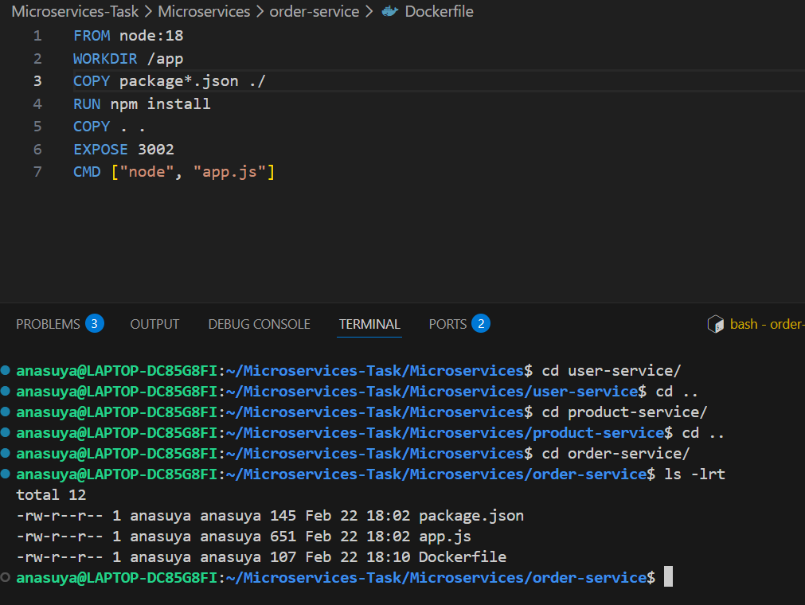

  - Gateway-service
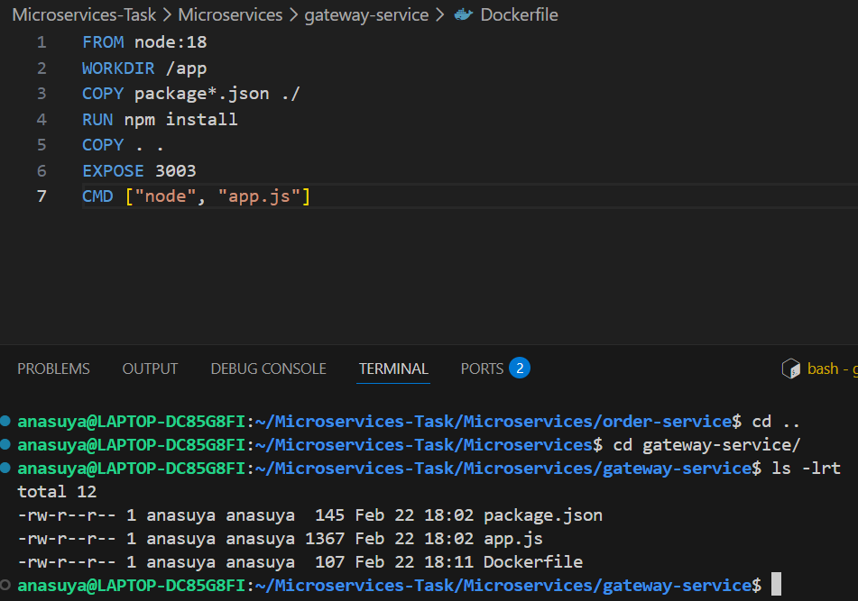

- Create Docker Compose file
  - Docker-compose.yml inside ~/Microservices-Task/Microservices
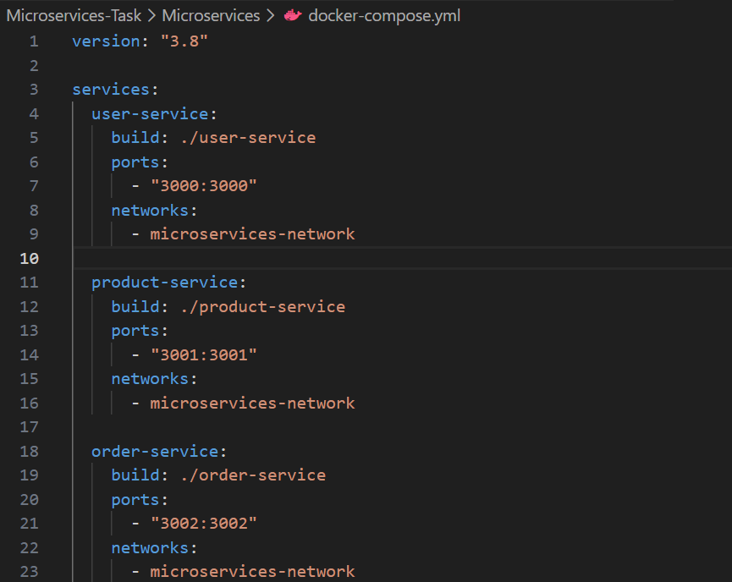
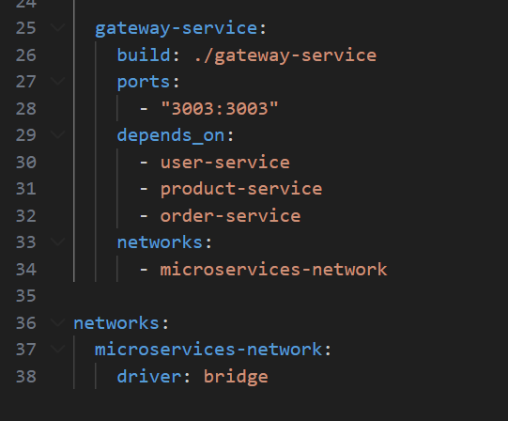

  - Build it

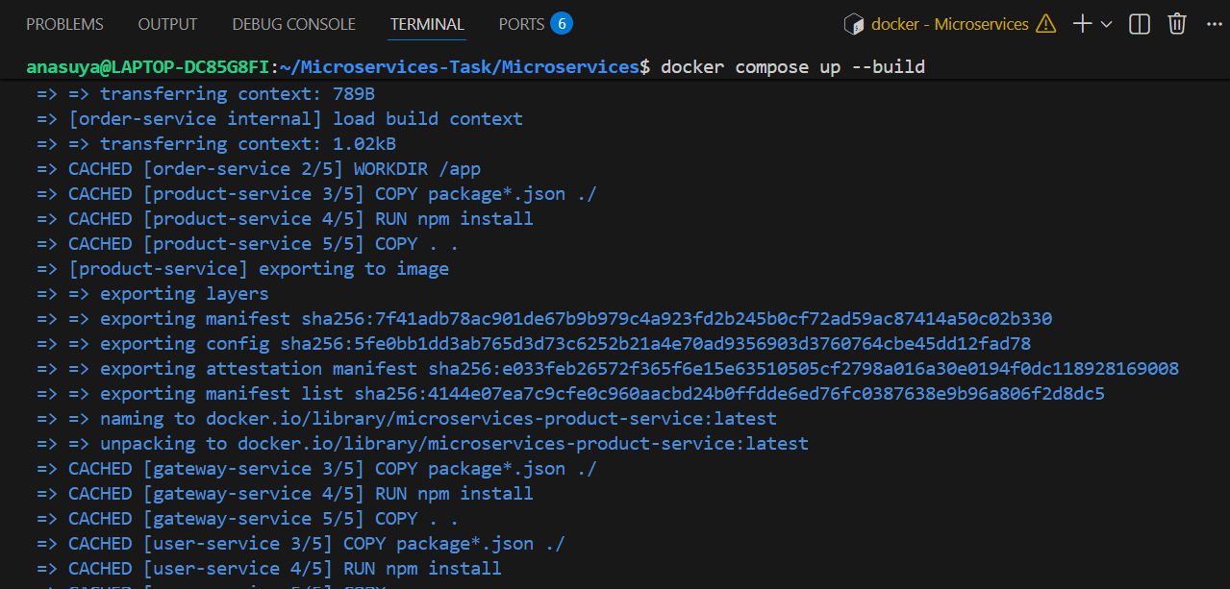
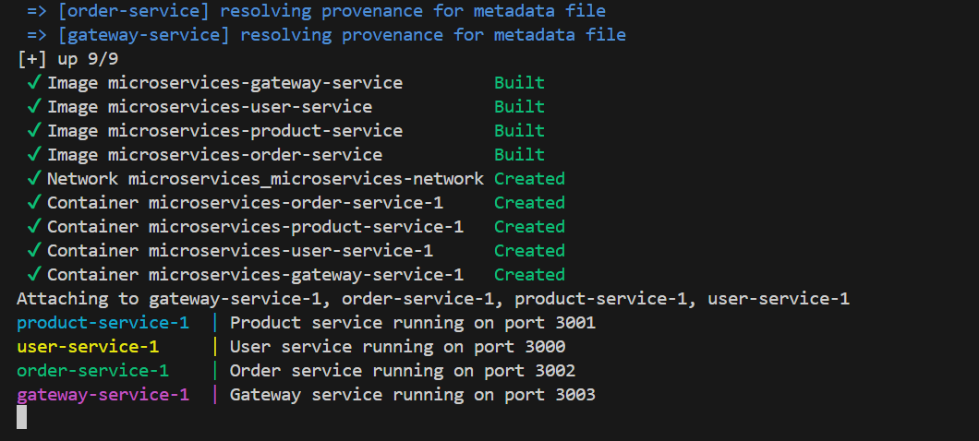

All four service containers are running :

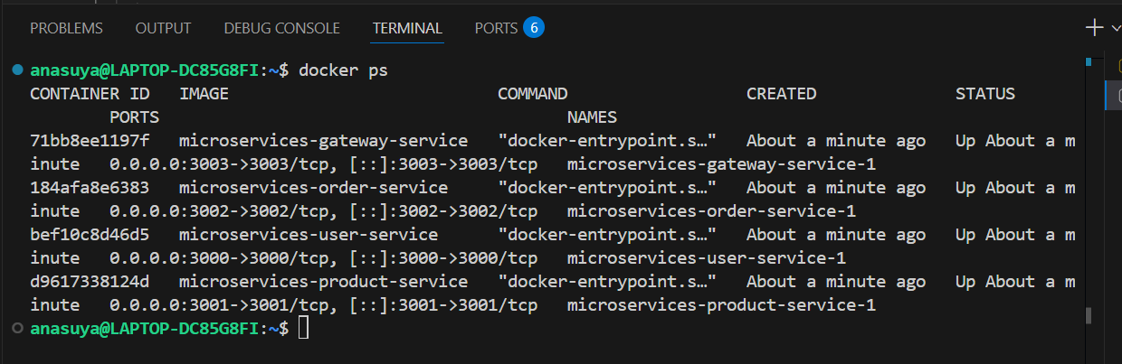

- Testing
  - User – Service End point – http://localhost:3000/users
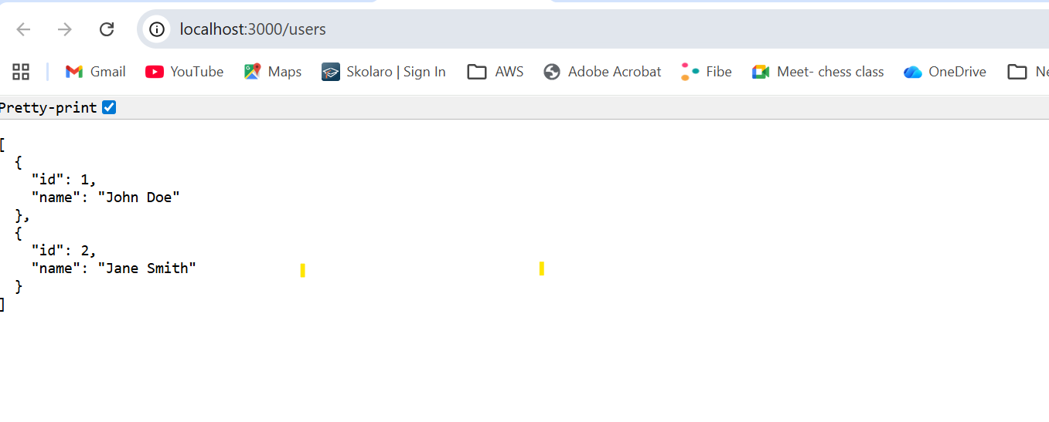b. Product -service - http://localhost:3001/products
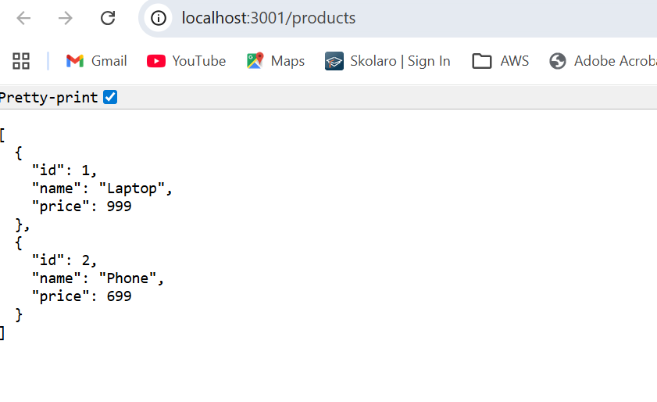c. order-service - http://localhost:3002/orders
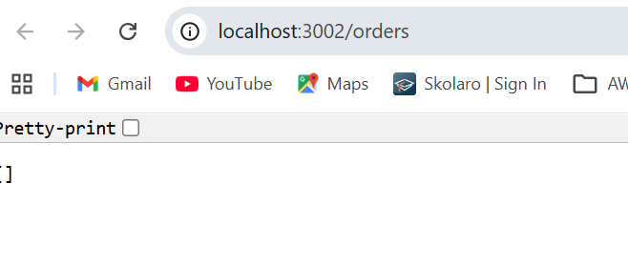

d. Gateway-service:
- http://localhost:3003/api/users
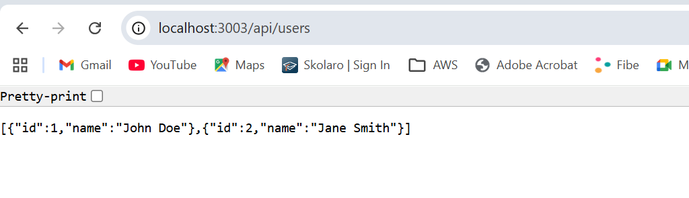
- http://localhost:3003/api/products
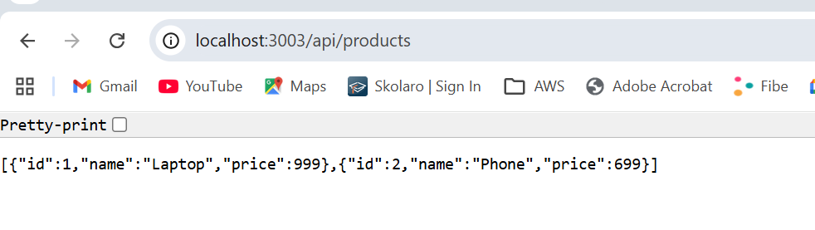
- http://localhost:3003/api/orders
